Measurement Protocol PAX

# General Information:

|  |  |  |
| --- | --- | --- |
| Test date: 19/02/20 | Date prev. test: | Test number: 1 |
| Tested by: Alex Pollak | PAX number: PB-009 | Installed at ant.:2H |
| Comments: Revision: 1.10 pax controller | | |
| Xpol very low output power for given detector value | | |
| Looks like broken amplifier | | |
|  | | |
| Known problems: | | |
|  | | |
|  | | |
|  | | |

# Setup:

|  |  |  |  |
| --- | --- | --- | --- |
| Power supply: | OK 🗹 NOK 🗆 | Communication: | OK 🗹 NOK 🗆 |
| Supply current +6V: 1.123A | | ssh obs@antcntl | |
| Supply current -6V: 0.177A | | ssh ataant@paxtester | pw: q@n@t |
| Supply current +5V: 0.216A | | telnet pax | “help” |
|  | | CTRL + ] | “close” |

# RF Test with VNA:

### VNA Setup:

|  |  |  |
| --- | --- | --- |
| Load configuration: Passband_PAX.csa | | |
| Freq Start: 1.0 GHz | Freq Stop: 13.0 GHz | Power Level: -20 dBm |
| Averaging: enabled | Averaging count: 15 | N. Points: 801 |
| VNA : Agilent N5230C 10MHz - 20GHz | | |

|  |  |  |  |  |
| --- | --- | --- | --- | --- |
| VNA to PAX connection: | 1m ABC-CA18 Cable + 20dB Attenuator | | | |
| Input Power Level to PAX: (Measured) | @1GHz:  -40.2dBm | @4GHz:  -40.7dBm | @8GHz: -41.2dBm | @12GHz: -41.4dBm |

|  |  |
| --- | --- |
| PAX to VNA connection: | 2m Fibre Cable + Fibre Diode + AOX Amplifier + 1m ABC-CA18 Cable |

### Measured Passband with Attenuator set to 7dB each (Complete Link):

|  |
| --- |
| X |

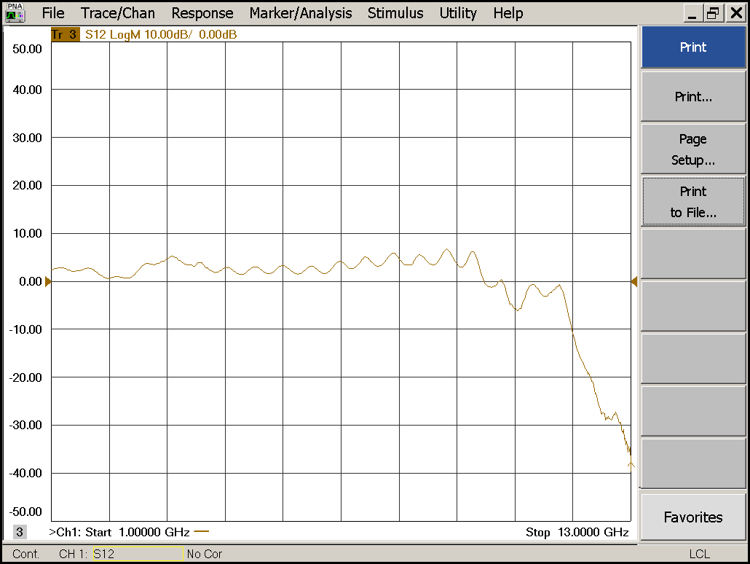

|  |  |  |  |
| --- | --- | --- | --- |
| Flatness: | OK 🗹 NOK 🗆 | Unwanted Features: | Yes ⮽ No 🗆 |

|  |
| --- |
| Y |

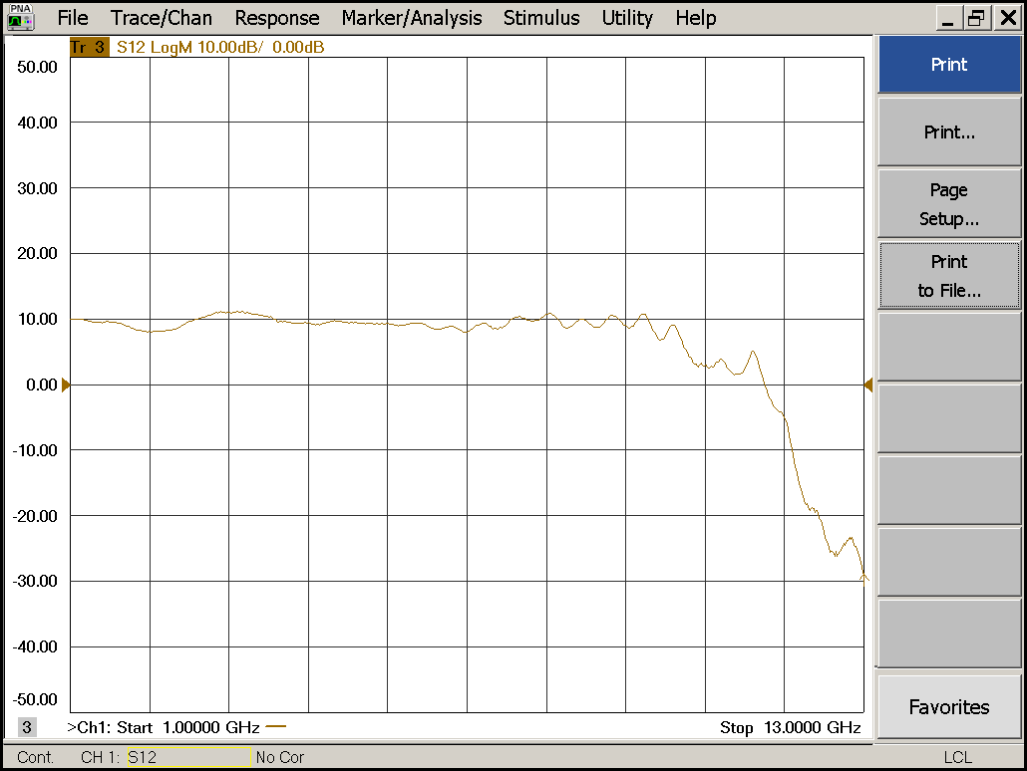

|  |  |  |  |
| --- | --- | --- | --- |
| Flatness: | OK 🗹 NOK 🗆 | Unwanted Features: | Yes 🗆 No 🗹 |

### Power Sweep (Complete Link):

|  |  |  |
| --- | --- | --- |
| Load configuration: Power_Sweep_PAX.csa | | |
| Power Start: -40dBm | Power Stop: -20dBm | Frequency : 4.0GHz |
| PAM Attenuator: 0dB |  | N. Points: 801 |

|  |
| --- |
| X |

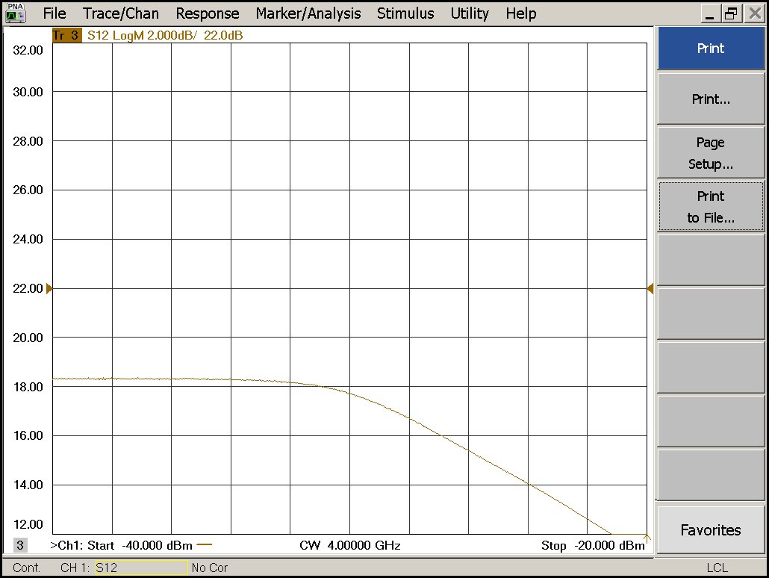

|  |  |  |  |
| --- | --- | --- | --- |
| Compression point: | OK 🗹 NOK 🗆 | Unwanted Features: | Yes 🗆 No 🗹 |

|  |
| --- |
| Y |

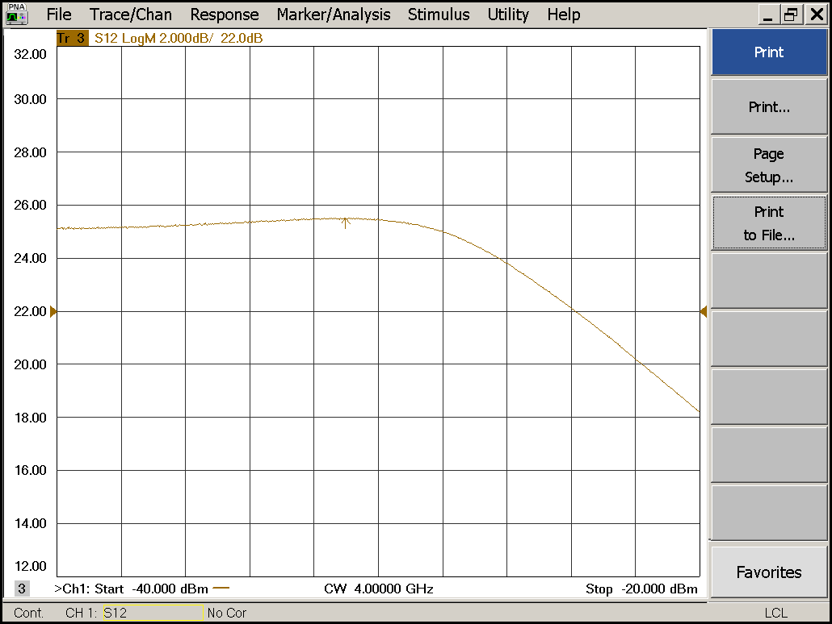

|  |  |  |  |
| --- | --- | --- | --- |
| Compression point: | OK 🗹 NOK 🗆 | Unwanted Features: | Yes 🗆 No 🗹 |

### Detector Calibration and Attenuator Sweep Pol X:

|  |  |  |
| --- | --- | --- |
| Load configuration: Detector_Calibration_PAX.csa | | |
| Freq : 4.0 GHz | Power Level: -20dBm | Sweep Time: -20sec |
| Sweep Mode: CW | Power Level at PAX Input (Measured): -40.6dBm | |

|  |  |  |  |  |
| --- | --- | --- | --- | --- |
| X | | | | |
| CW Input Power [dBm]: | Attenuator Value A [dB]: | Attenuator Value: B [dB]: | Detector Value: | Power Meter  Value [dBm]: |
| -40.6 | 0 | 0 | - | 7.8 |
| -40.6 | 0 | 3 | - | 7.6 |
| -40.6 | 0 | 6 | - | 6.2 |
| -40.6 | 0 | 9 | - | 4.3 |
| -40.6 | 0 | 12 | - | 1.7 |
| -40.6 | 0 | 15 | 0.8618 | -1.1 |
| -40.6 | 0 | 18 | 0.8562 | -4.4 |
| -40.6 | 0 | 21 | 0.4712 | -7.4 |
| -40.6 | 3 | 21 | 0.2310 | -10.7 |
| -40.6 | 6 | 21 | 0.1182 | -13.7 |
| -40.6 | 9 | 21 | 0.0603 | -16.7 |
| -40.6 | 12 | 21 | 0.0310 | -19.6 |
| -40.6 | 15 | 21 | 0.0165 | -22.5 |
| -40.6 | 18 | 21 | 0.0083 | -25.8 |
| -40.6 | 21 | 21 | 0.0046 | -28.9 |
| -40.6 | 24 | 21 | 0.0030 | -31.7 |
| -40.6 | 27 | 21 | 0.0021 | -34.7 |
| -40.6 | 30 | 21 | 0.0015 | -37.8 |
| -40.6 | 30 | 24 | 0.0014 | -40.4 |
| -40.6 | 30 | 27 | 0.0013 | -42.8 |
| -40.6 | 30 | 30 | 0.0012 | -45.0 |

|  |  |  |
| --- | --- | --- |
| Use Noise Source: Atlantic AS6333 | | |
| Freq : 1.0 - 12.0GHz | Power Level: -41.8dBm |  |
| DC Supply: 28V |  | |

|  |  |  |  |  |
| --- | --- | --- | --- | --- |
| X | | | | |
| Input Power [dBm]: | Attenuator Value A [dB]: | Attenuator Value: B [dB]: | Detector Value: | Power Meter  Value [dBm]: |
| -41.8 | 0 | 0 | - | 6.3 |
| -41.8 | 0 | 3 | - | 5.4 |
| -41.8 | 0 | 6 | - | 3.9 |
| -41.8 | 0 | 9 | - | 1.9 |
| -41.8 | 0 | 12 | - | -0.8 |
| -41.8 | 0 | 15 | 0.8612 | -3.4 |
| -41.8 | 0 | 18 | 0.8235 | -6.6 |
| -41.8 | 0 | 21 | 0.4418 | -9.5 |
| -41.8 | 3 | 21 | 0.2277 | -12.4 |
| -41.8 | 6 | 21 | 0.1119 | -15.5 |
| -41.8 | 9 | 21 | 0.0575 | -18.4 |
| -41.8 | 12 | 21 | 0.0289 | -21.5 |
| -41.8 | 15 | 21 | 0.0163 | -24.1 |
| -41.8 | 18 | 21 | 0.0083 | -27.4 |
| -41.8 | 21 | 21 | 0.0048 | -30.5 |
| -41.8 | 24 | 21 | 0.0031 | -33.5 |
| -41.8 | 27 | 21 | 0.0023 | -36.1 |
| -41.8 | 30 | 21 | 0.0018 | -39.3 |
| -41.8 | 30 | 24 | 0.0016 | -41.8 |
| -41.8 | 30 | 27 | 0.0015 | -43.9 |
| -41.8 | 30 | 30 | 0.0014 | -45.8 |

### Detector Calibration and Attenuator Sweep Pol Y:

|  |  |  |
| --- | --- | --- |
| Load configuration: Detector_Calibration_PAX.csa | | |
| Freq : 4.0 GHz | Power Level: -20dBm | Sweep Time: -20sec |
| Sweep Mode: CW | Power Level at PAX Input (Measured): -40.6dBm | |

|  |  |  |  |  |
| --- | --- | --- | --- | --- |
| Y | | | | |
| CW Input Power [dBm]: | Attenuator Value A [dB]: | Attenuator Value: B [dB]: | Detector Value: | Power Meter  Value [dBm]: |
| -40.6 | 0 | 0 | - | 13.4 |
| -40.6 | 0 | 3 | - | 13.4 |
| -40.6 | 0 | 6 | - | 12.9 |
| -40.6 | 0 | 9 | - | 10.8 |
| -40.6 | 0 | 12 | 0.8524 | 7.9 |
| -40.6 | 0 | 15 | 0.7253 | 5.1 |
| -40.6 | 0 | 18 | 0.4164 | 1.8 |
| -40.6 | 0 | 21 | 0.2394 | -1.2 |
| -40.6 | 3 | 21 | 0.1232 | -4.6 |
| -40.6 | 6 | 21 | 0.0659 | -7.6 |
| -40.6 | 9 | 21 | 0.0344 | -10.7 |
| -40.6 | 12 | 21 | 0.0179 | -13.7 |
| -40.6 | 15 | 21 | 0.0095 | -16.6 |
| -40.6 | 18 | 21 | 0.0049 | -19.9 |
| -40.6 | 21 | 21 | 0.0028 | -23.0 |
| -40.6 | 24 | 21 | 0.0018 | -25.9 |
| -40.6 | 27 | 21 | 0.0013 | -28.9 |
| -40.6 | 30 | 21 | 0.0011 | -32.1 |
| -40.6 | 30 | 24 | 0.0010 | -34.7 |
| -40.6 | 30 | 27 | 0.0009 | -37.3 |
| -40.6 | 30 | 30 | 0.0009 | -39.6 |

|  |  |  |
| --- | --- | --- |
| Use Noise Source: Atlantic AS6333 | | |
| Freq : 1.0 - 12.0GHz | Power Level: -41.8dBm |  |
| DC Supply: 28V |  | |

|  |  |  |  |  |
| --- | --- | --- | --- | --- |
| Y | | | | |
| Input Power [dBm]: | Attenuator Value A [dB]: | Attenuator Value: B [dB]: | Detector Value: | Power Meter  Value [dBm]: |
| -41.8 | 0 | 0 | - | 11.8 |
| -41.8 | 0 | 3 | - | 10.8 |
| -41.8 | 0 | 6 | - | 9.2 |
| -41.8 | 0 | 9 | 0.8521 | 7.0 |
| -41.8 | 0 | 12 | 0.8493 | 4.4 |
| -41.8 | 0 | 15 | 0.5448 | 1.8 |
| -41.8 | 0 | 18 | 0.3029 | -1.3 |
| -41.8 | 0 | 21 | 0.1700 | -4.2 |
| -41.8 | 3 | 21 | 0.0892 | -7.2 |
| -41.8 | 6 | 21 | 0.0451 | -10.3 |
| -41.8 | 9 | 21 | 0.0237 | -13.2 |
| -41.8 | 12 | 21 | 0.0122 | -16.3 |
| -41.8 | 15 | 21 | 0.0070 | -19.0 |
| -41.8 | 18 | 21 | 0.0038 | -22.3 |
| -41.8 | 21 | 21 | 0.0024 | -25.3 |
| -41.8 | 24 | 21 | 0.0017 | -28.3 |
| -41.8 | 27 | 21 | 0.0014 | -31.1 |
| -41.8 | 30 | 21 | 0.0012 | -34.3 |
| -41.8 | 30 | 24 | 0.0011 | -36.8 |
| -41.8 | 30 | 27 | 0.0011 | -38.9 |
| -41.8 | 30 | 30 | 0.0011 | -40.8 |

# Inspection:

### Visual:

|  |  |  |
| --- | --- | --- |
| Fibre Connectors Clean | Comments: | OK 🗹 NOK 🗆 |
| Fibre Connector Mechanical | Comments: | OK **🗹** NOK **🗆** |
| RF Cable | Comments: | OK **🗹** NOK **🗆** |
| RF Connectors Clean | Comments: | OK **🗹** NOK **🗆** |

### Functions:

|  |  |  |
| --- | --- | --- |
| Read Temperature Value | Comments: 30.3 | OK 🗹 NOK 🗆 |
| LNA Settings | Comments: | OK**🗹** NOK **🗆** |
| Temperature Stabilisation | Comments: | OK 🗆 NOK **🗆** |
|  |  | OK 🗆 NOK **🗆** |